**SobelGradiantEdgeDetectors_Data.txt:**

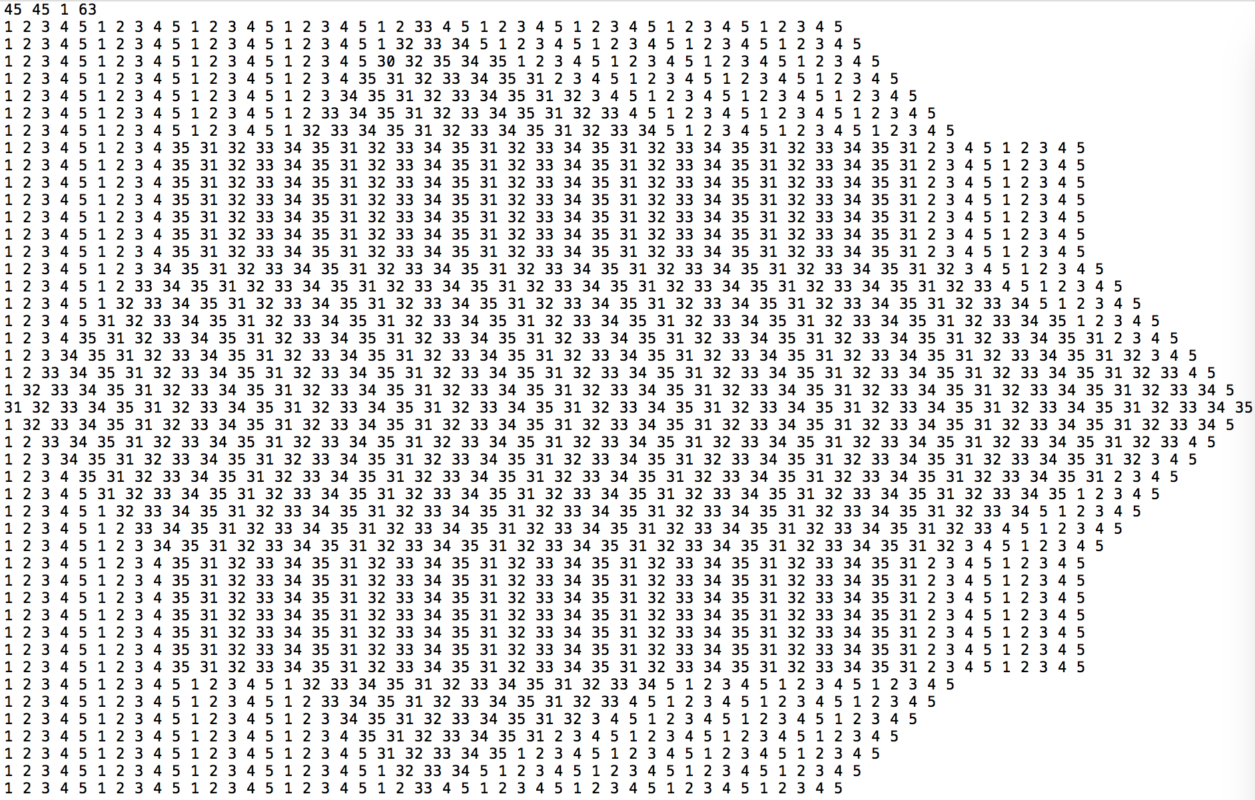

**SobelVertical.txt: SobelVertical_thr_13_PP.txt:**

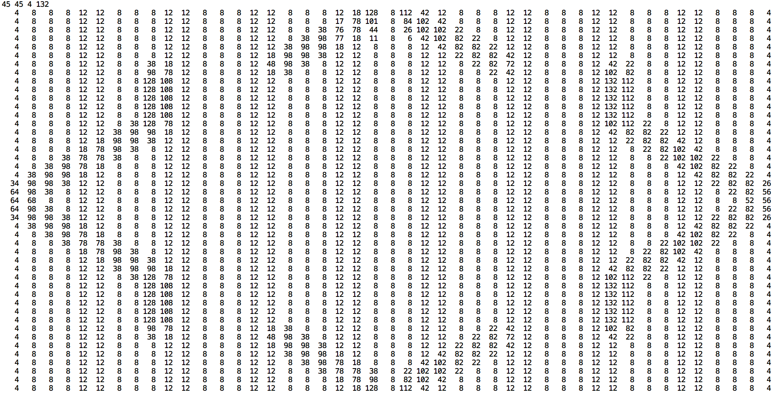 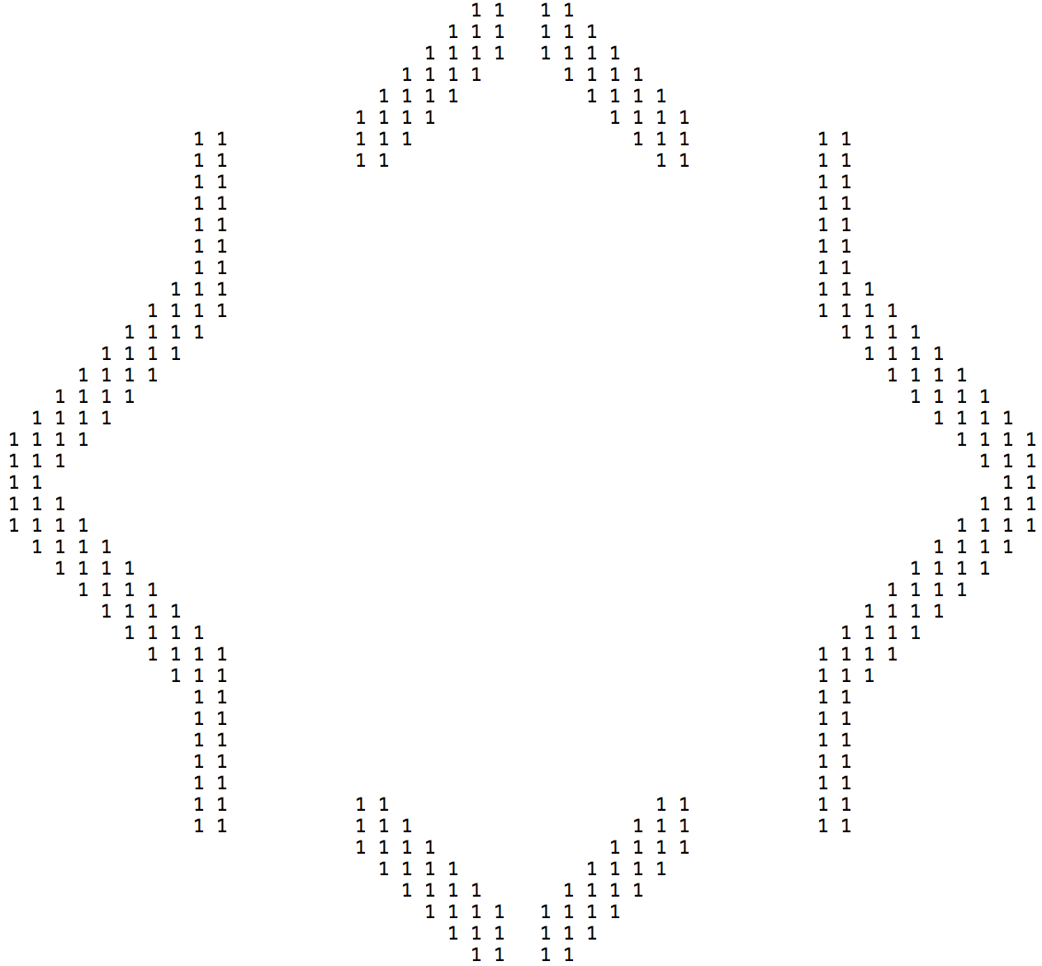

**SobelHorizontal.txt: SobelHorizontal_thr_1_PP.txt:**

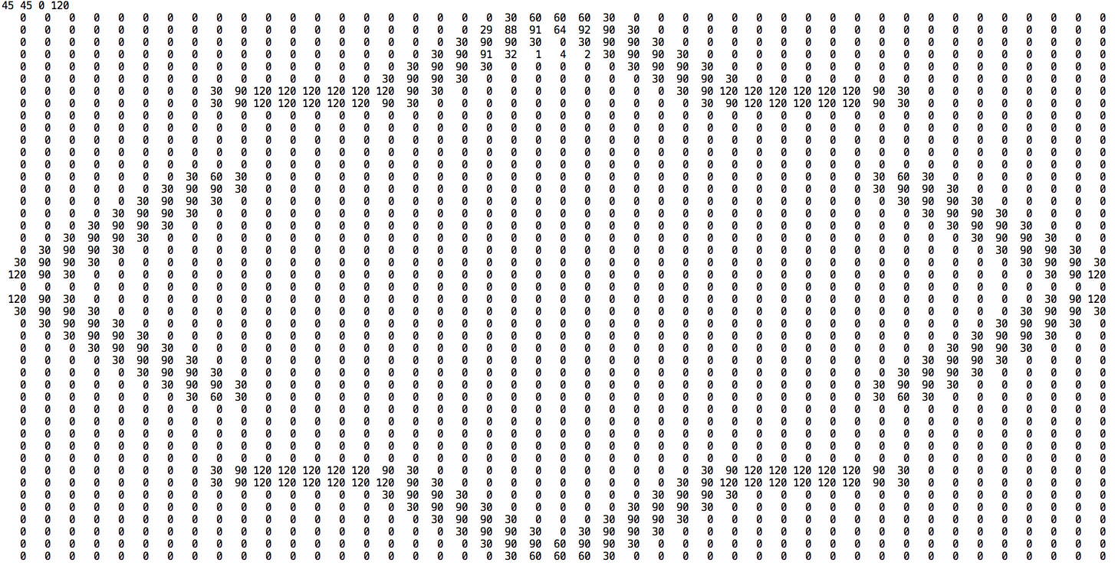 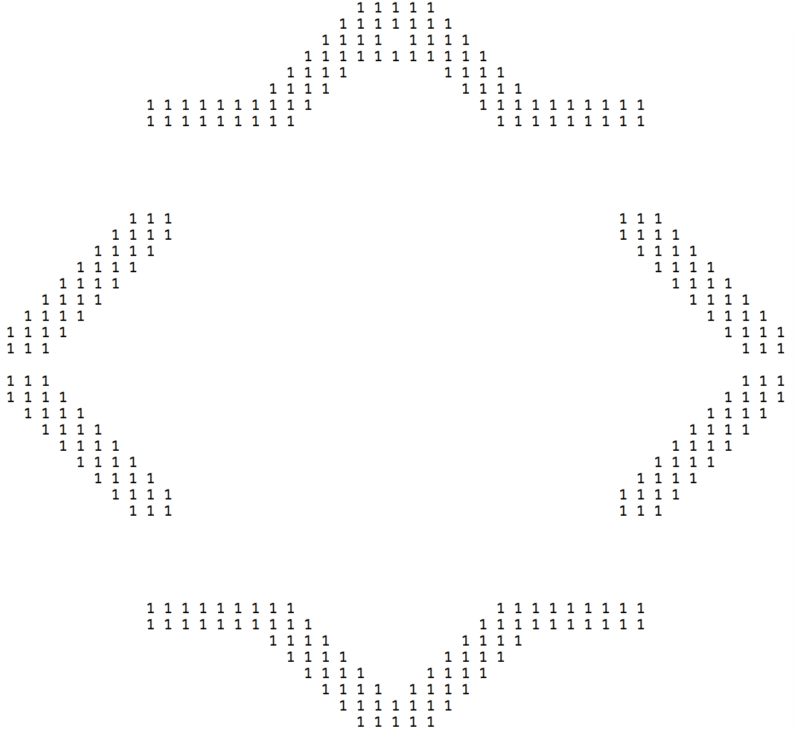

**SobelRightDiag.txt: SobelRightDiag_thr_10_PP.txt:**

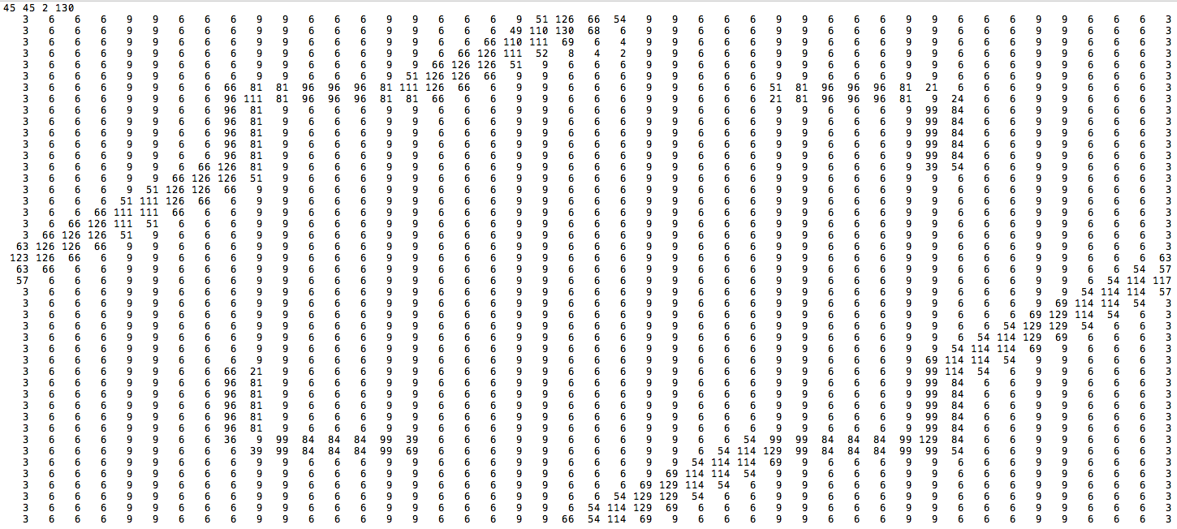 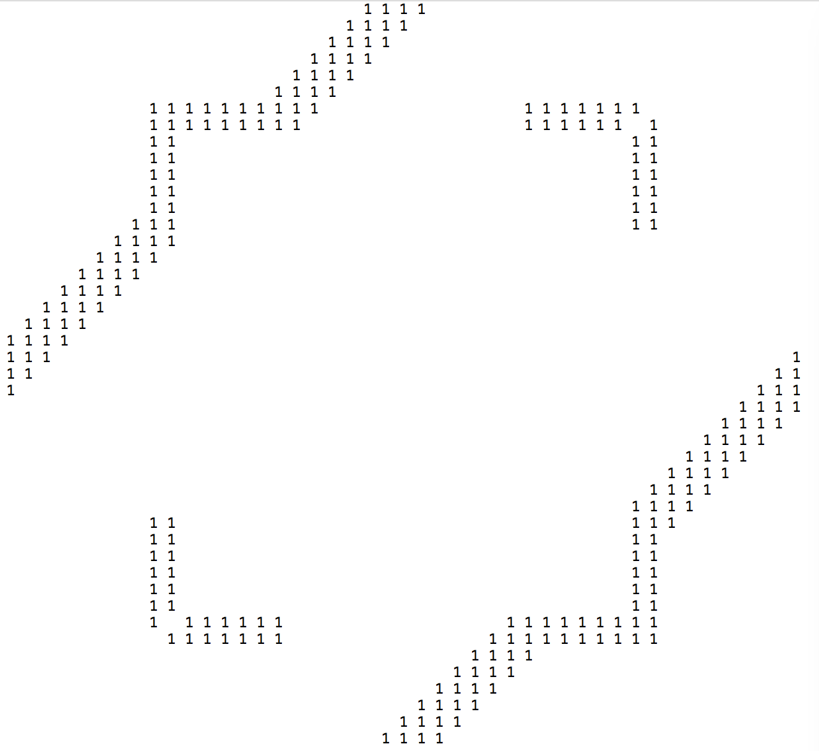

**SobelLeftDiag.txt: SobelLeftDiag_thr_12_PP.txt:**

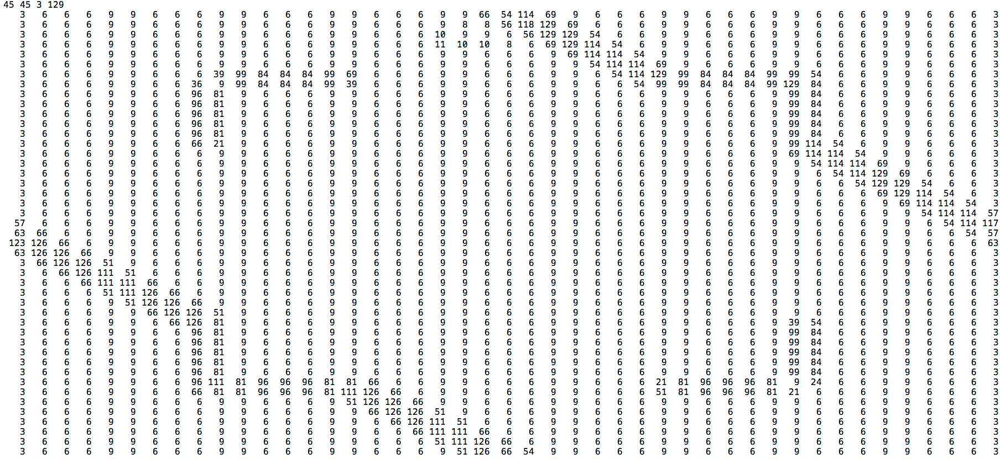 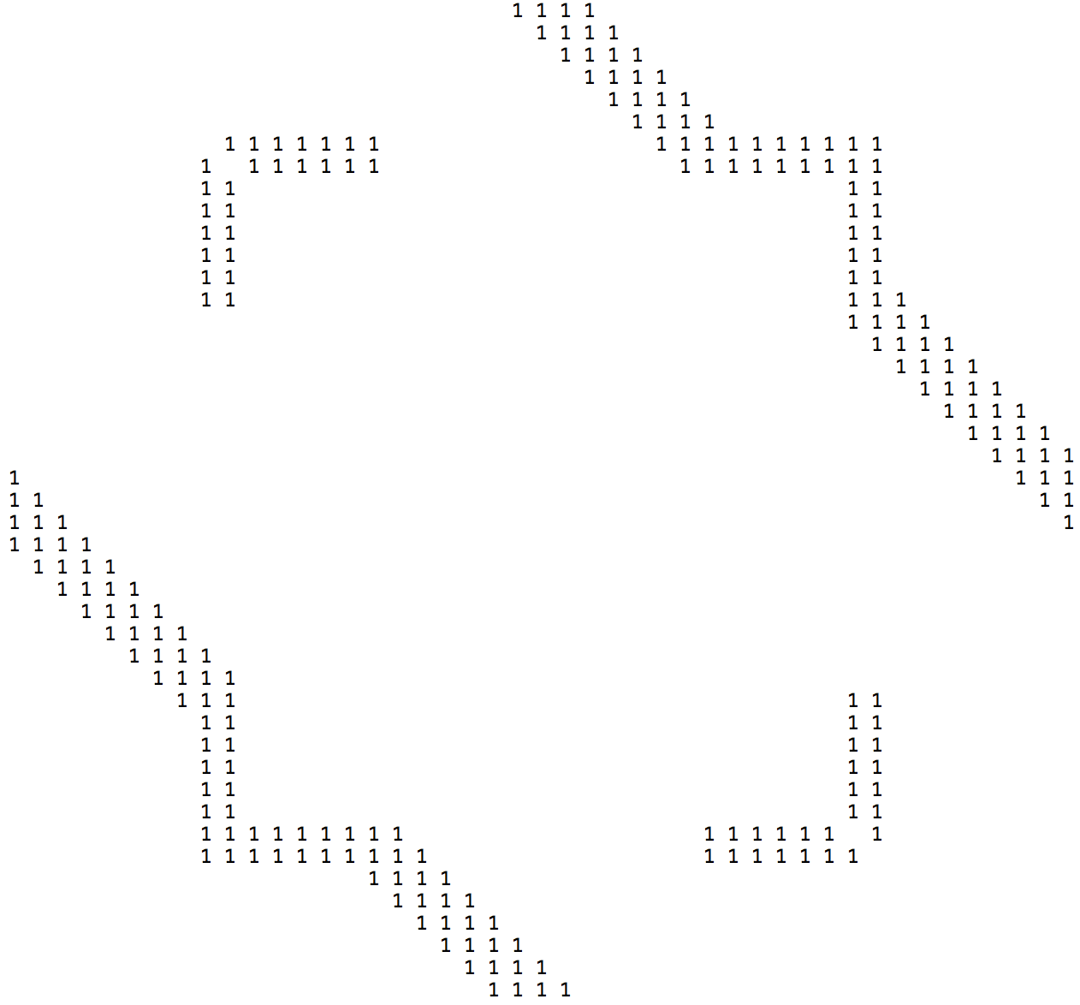

**GradiantEdge_thr_5_PP.txt: GradiantEdge_thr_5_PP.txt:**

